# CREATE A SERVICE CALL - STANDARD

**CREATE AND MANAGE NAXT QUICK LINKS**

## Introduction

You can create and manage links to websites from your NAXT home page. These quick links act in the same way as favourites or bookmarked links in your web browser.

## Create a NAXT Quick link

**Step 1: Navigate to your NAXT home page**

Select the ‘Home’ icon. On the right hand side of this display you should see ‘Quick links’.

**Step 2: Create a Quick link**

Select the ‘Add links’ option; the ‘Add Quick Link’ window will pop up.

**Step 3: Enter the web address details**

Select the ‘URL’ radio button then enter the full web address into the URL field.

Give the web address a name in the ‘Title’ field. This is how it will display on the NAXT home page.

Select the ‘OK’ button and you’re done.

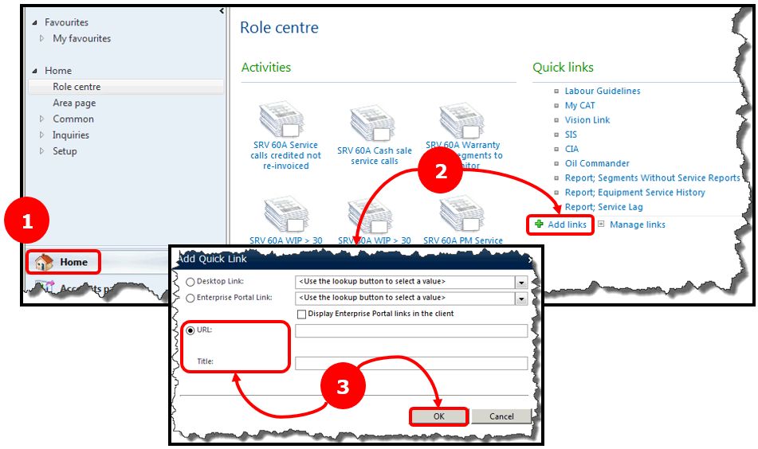

## Manage a NAXT Quick link

**Step 1: Navigate to your NAXT home page**

Select the ‘Home’ icon. On the right hand side of this display you should see ‘Quick links’.

**Step 2: Manage a Quick link**

Select the ‘Manage links’ option; the ‘Manage Quick Links’ window will pop up.

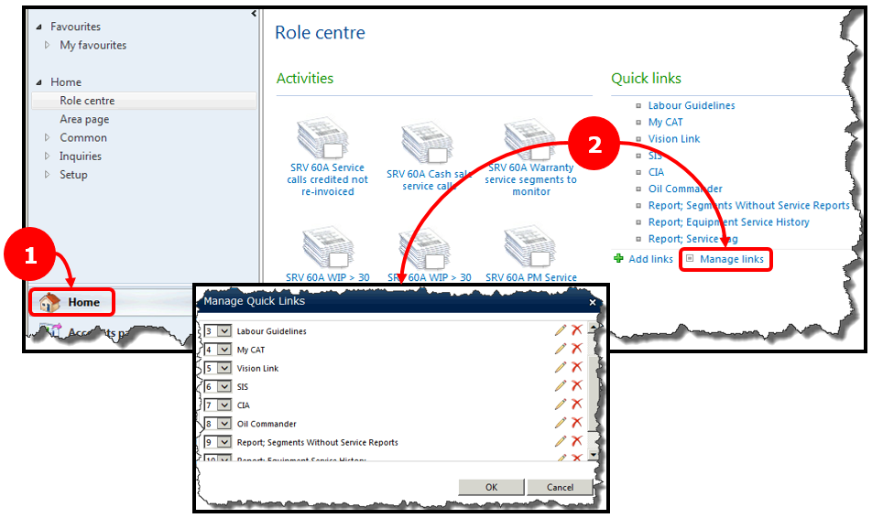

What do you want to do next?

* **I want to adjust the rank of my quick links; see Step 3A.**
* **I want to edit one of my quick links; see Step 3B.**
* **I want to delete one of my quick links; see Step 3C.**

**Step 3A: Adjust the order of your quick links**

Select the drop down arrow next to the quick link you want to adjust.

Select ‘URL’ radio button then enter the full web address into the URL field.

Give the web address a name in the ‘Title’ field. This is how it will display on the NAXT home page.

Select the ‘OK’ button and you’re done.

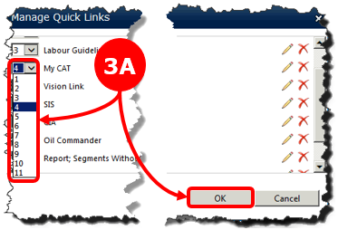

**Step 3B: Edit the web address and/or name of a quick link**

Select the pencil icon next to the link you want to edit; the ‘Edit Quick Link’ window will pop up.

Edit the web address and/or title for the quick link.

Select the ‘OK’ button and you’re done.

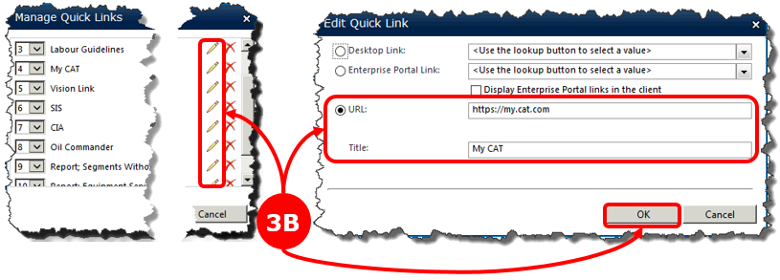

**Step 3C: Remove a quick link**

Select the red ‘x’ icon next to the link you want to delete. A warning window will pop up.

Select the ‘OK’ button and you’re done.

